Gift Aid Form
Mr/Mrs/Miss/Ms

Name
Address
Post code
Email
Phone
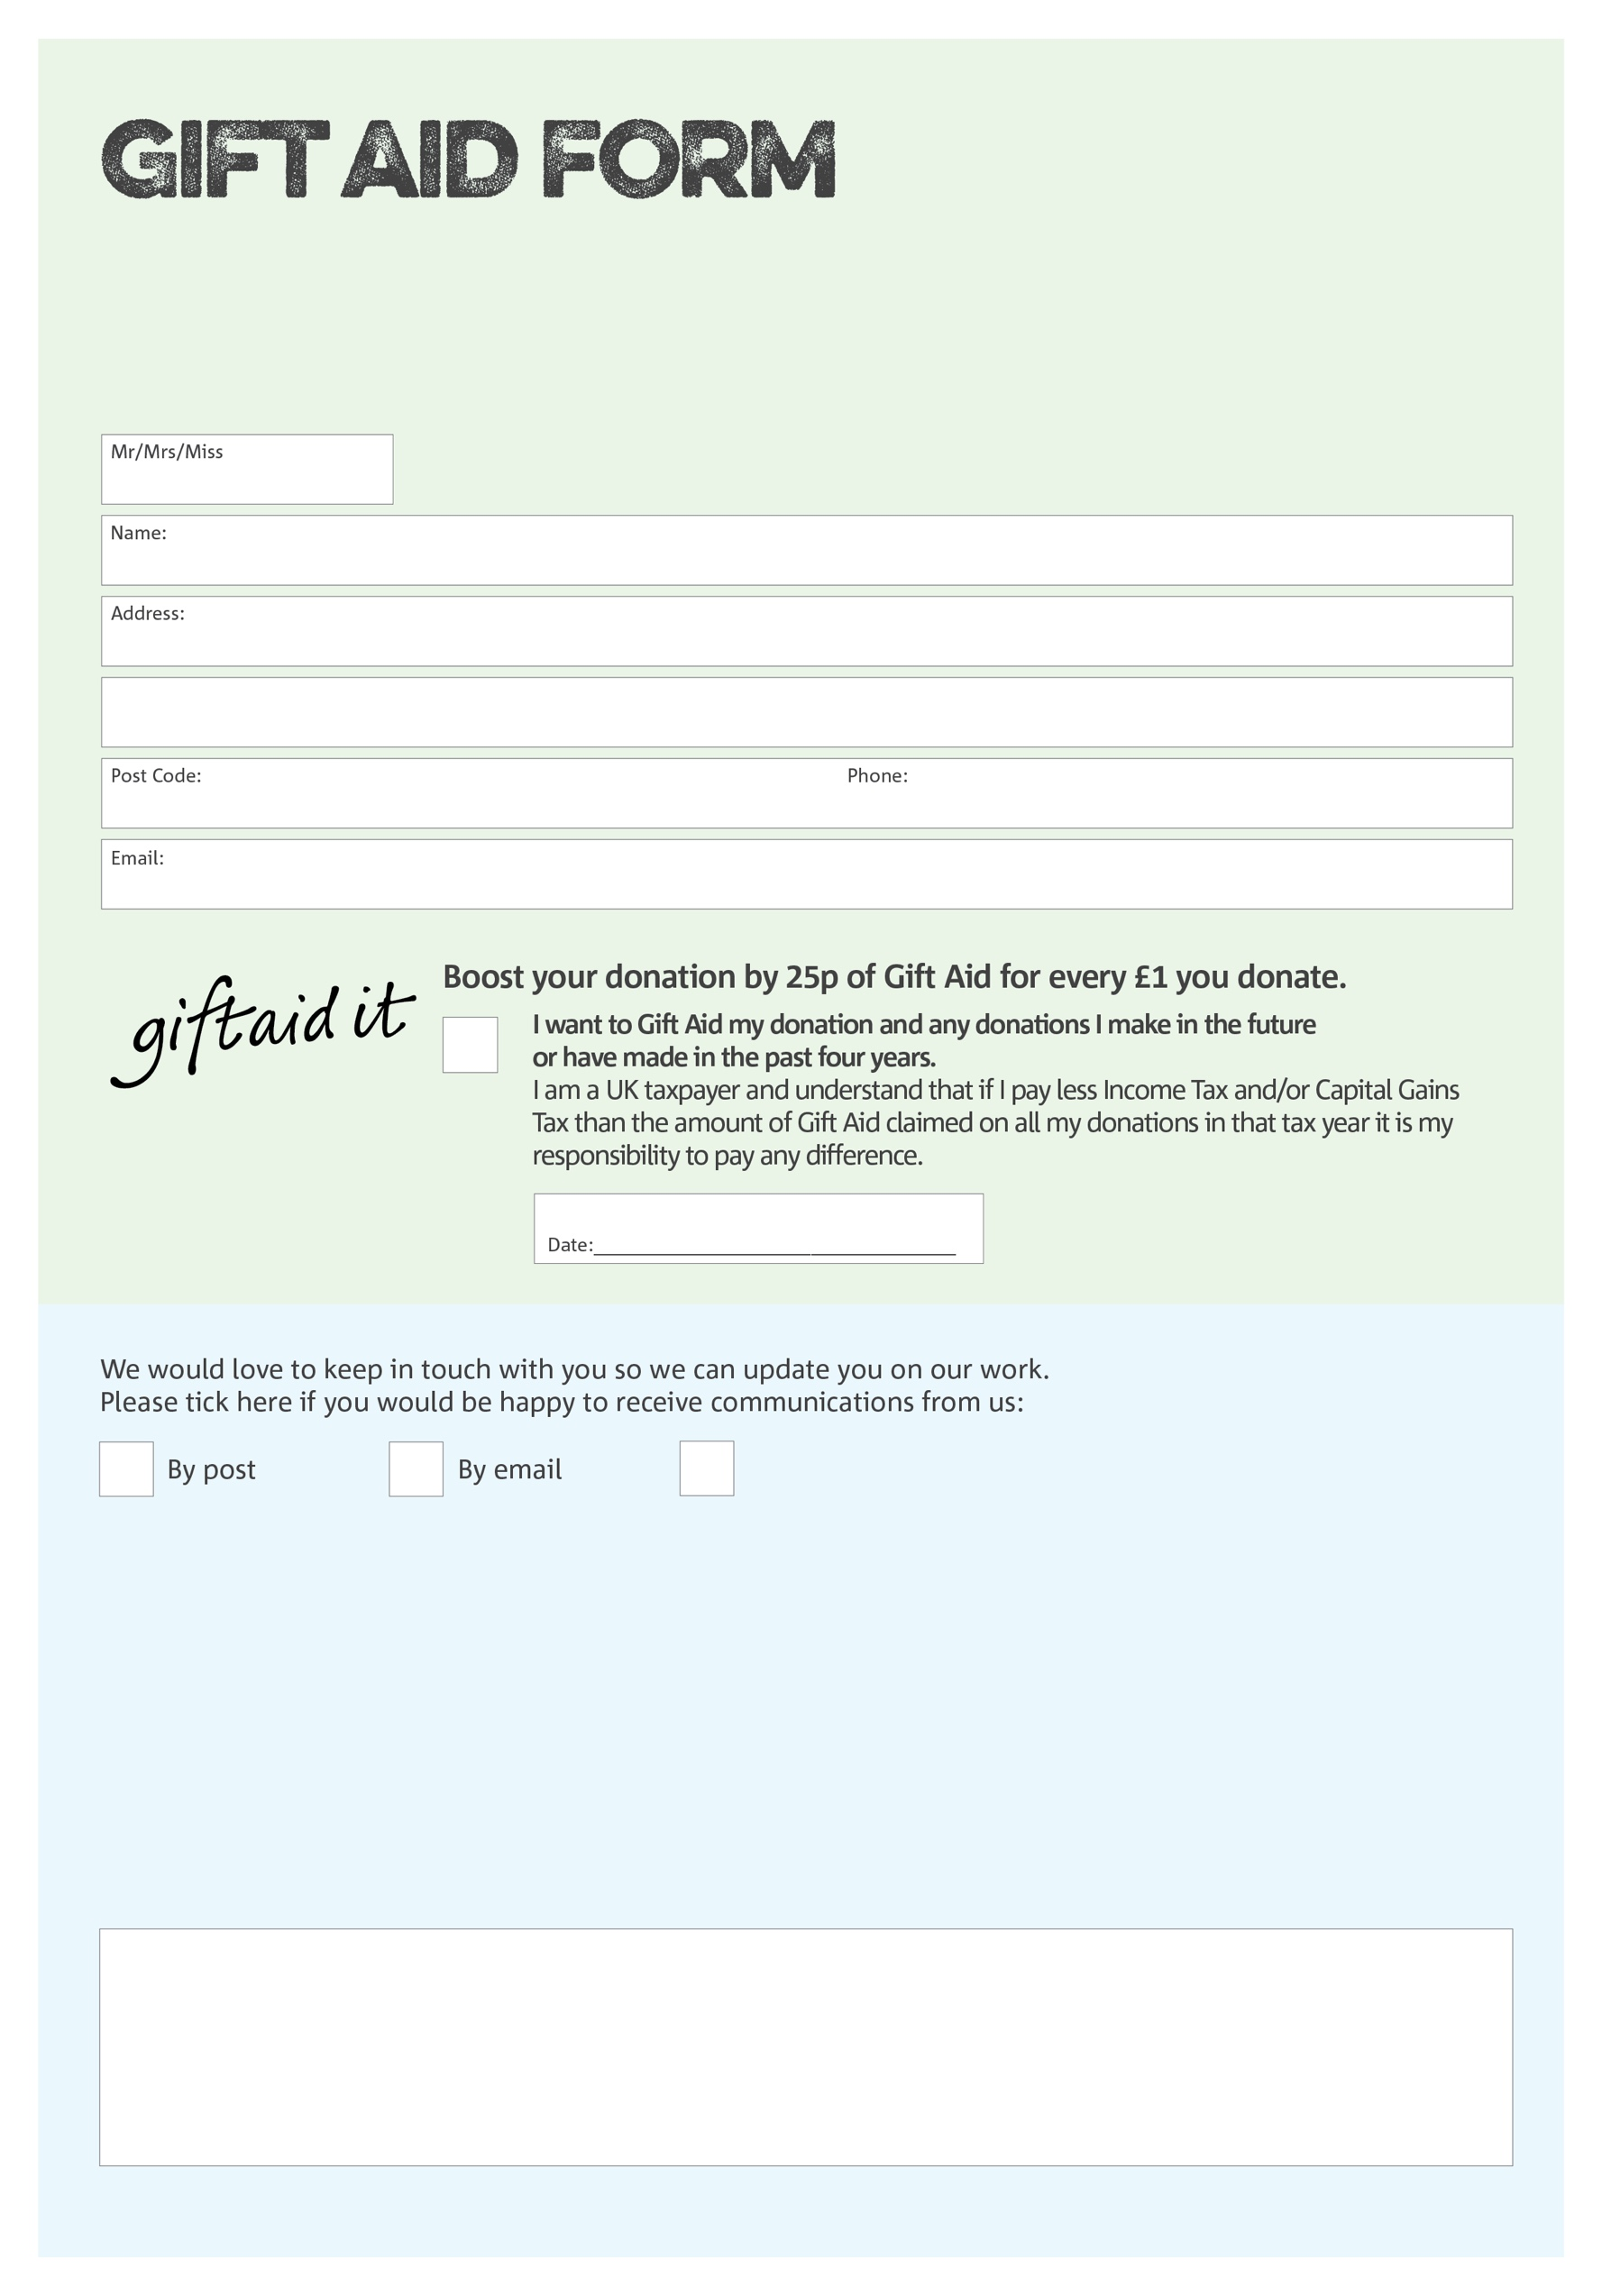

Data protection

Oldham Foodbank is committed to protecting your privacy and will process your personal data in accordance with current Data Protection legislation. Oldham Foodbank collects information to keep in touch with you and supply you with information relating to our work. To unsubscribe from our newsletter, send a message to the email address above with the word unsubscribe in the subject line. A full data privacy statement for financial donors is available from the foodbank on request.’

You can change your preferences any time by contacting us on 0161 622 1061 or emailing us at
info@oldham.foodbank.org.uk
We would love to know why you have chosen to donate to Oldham Foodbank. If you would like to share your motivation let us know below:

